Use-Case Realization Report
DeleteRole

Issue <1.0>
Revision History
Date | Issue | Description | Author
<dd/mmm/yy> | <x.x> | <details> | <name>

Table of Contents
1. Brief Description 4
2. Flow of Events 4
2.1 Standard Flow 4
2.2 Exceptions 4
3. Interaction Diagrams 4
3.1 Collaboration Diagram for Delete Role 4
4. Participating Objects 5
5. Class Diagrams 5
5.1 Class Diagram for Delete Role 5
6. Derived Requirements 5

Use-Case Realization Report
DeleteRole

Brief Description
This shall be used to delete the Role and show the updated list after deletion.

Flow of Events

Standard Flow
This use case covers the events of deleting Role, which is part of the Maintenance Role package. The standard flow of events is described as below:
- The Portal Administrator shall press the button to send out a command of “deleteButtonClicked” on the interface of MaintainRolePage.
- Then RoleController will check if there’s Role selected to be deleted through the operation checkRoleToDelete.
- The selected role will get from the Role object, then it will be deleted.
- The RoleController shall get back the role list then display the new list on the MaintainRolePage.

Exceptions
- If there’s no Role selected, a message will be sent to MaintainRolePage through the operation showNoRoleSelectedMsg.

Interaction Diagrams

Collaboration Diagram for Delete Role
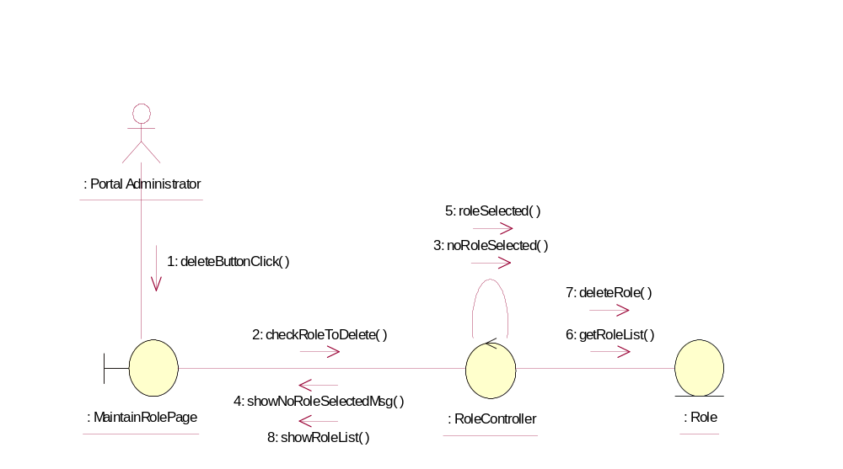

Participating Objects
: Role
This object shall store the list of the Role

: RoleController

This Controller shall interface with the boundary to remove the selected Role and retrieve the Role information from the object and delete appropriately.

: MainrainRolePage

This boundary shall display the selection for the actor and to show the updated RoleList from the RoleController.

: Portal Administrator

This actor shall perform the necessary action on the boundary.

Class Diagrams

Class Diagram for Delete Role
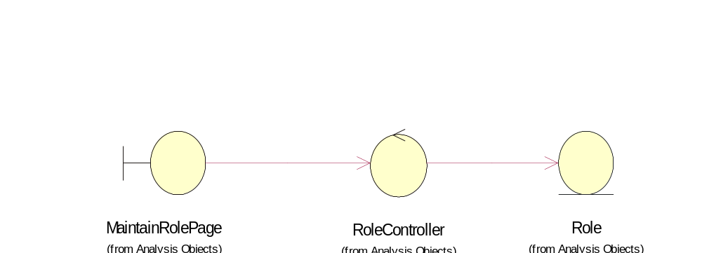

Derived Requirements
Only Portal Administrator has rights to access this page

